**2e - Prediction**

Do you think that ***Quote*** will…?

|  |  |
| --- | --- |
|  | Tick **one.** |
| yes |  |
| no |  |
| maybe |  |

Explain your choice fully, using evidence from the text.

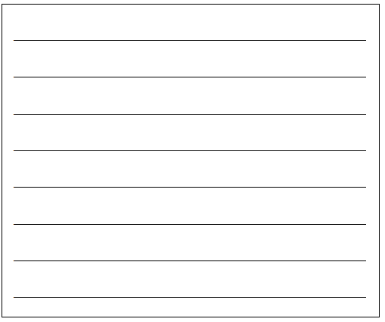

3 marks