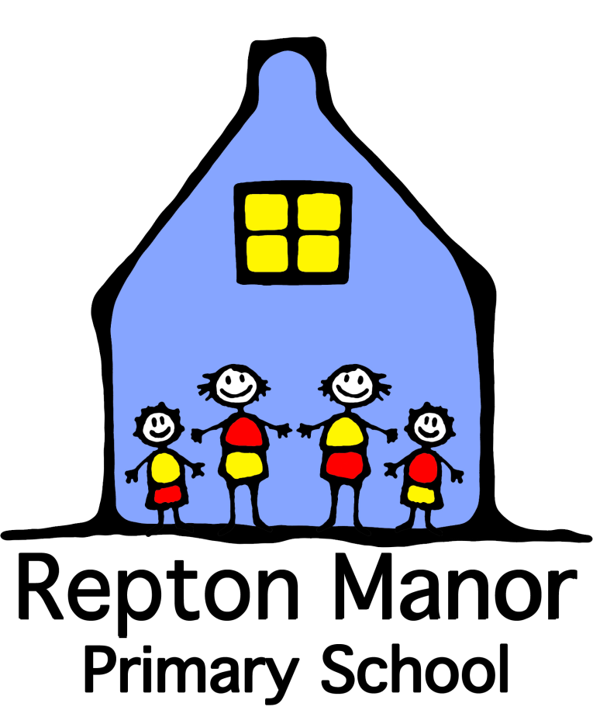

**Early Years Foundation Stage Policy**

|  |  |  |
| --- | --- | --- |
| **Written by** | Jessica Iles | **Signed** |
| **Uploaded** |  |  |
| **Date approved by Governing Body** | 15th January 2025 | Local Governing Committee |
| **Reviewed** |  |  |

**Early Years Policy**

**Vision**

Upon starting the Early Years at Repton Manor children will be invited into an enriched environment which enables them to make independent choices, develop interests, build resilience and ignite curiosity. Within this carefully thought about environment adults have a deep understanding of how children learn and develop in the Early Years specifically. Adults spend time becoming engrossed in shared thinking and discussion, they know how to move learning on in a purposeful way. We ensure every child’s voice is heard and individual needs are met through rigorous plan, do, review cycles for individuals and groups. All areas of the EYFS curriculum are valued and significant importance is placed in developing the Prime areas. It is important to us that children are given real life experiences which they are able to draw upon using their skills and knowledge to build links between different areas of learning. You will find our children outside come rain or shine, experiencing the weather and the changing seasons. We see our Early Years children as endlessly capable individuals.

The Reception year must provide every child with a feeling of security, being valued and the confidence to explore new learning.

The EYFS is based on four overarching principles:

* Every child is a unique child, who is constantly learning and can be resilient, capable, and confident.
* Children learn to be strong and independent through positive relationships.
* Children learn and develop well in enabling environments, in which their experiences respond to their individual needs and there is a strong partnership between practitioners and parents and/or carers
* Children develop and learn in different ways and at different rates.

**Aims and Principles**

* Foundation Stage teachers and teaching assistants should ensure that all children feel part of the school community, secure and valued. Initially this will be exclusively the Early Year setting and as the year develops will move into the wider school.
* To provide a relevant curriculum with tasks that take into account the children’s interests and fascinations and are both practical and purposeful. The children will be taught through stimulating topics, these are developed with the children in mind e and develop specific interests they have expressed. The teachers will also plan many activities and tasks which are centred around skills the children need to develop, these are targeted through observation and work alongside the child.
* To provide quality opportunities for children to engage in activities planned by adults and those that children plan or self-initiate. Teachers must plan a challenging and enjoyable experience in all areas of learning and development.
* Practitioners acknowledge the holistic nature of young children’s learning and natural links will be made between different areas of the curriculum, with the emphasis on learning through play and the importance of developing the prime areas of the Foundation Stage Curriculum.
* Practitioners always endeavour to create a learning environment that develops children’s independence and encourages children to explore and express their ideas and feelings.

**Planning and organising the curriculum**

There are seven areas of learning and development that must provide a framework for planning, teaching and assessing in early years settings. All areas of learning and development are interconnected.

The three prime areas are:

Communication and Language

Children will be given a range of opportunities to experience a rich language environment, to develop their ability to express themselves and to speak and listen in a range of situations. There has been a huge emphasis placed on this area of development, this is due to a decline in children’s language skills and the rise in children with language disorders. We will talk to parents often about their child’s speech and language development as we believe the ability to communicate opens such an exciting door to learning opportunities.

Physical Development

Children will be provided with lots of opportunities to be active; to develop their coordination, motor control and movement. Children will be able to explore the environment at Repton Manor, including the adventure trail, nature area and the large equipment in the school hall. We place a huge importance on children’s physical development as we are acutely aware of the developmental steps children need to move through before becoming writers. Children will be taught the importance of physical activity and to make healthy choices in relation to lifestyle.

Personal, Social and Emotional Development

This is a vital area of development for children to develop a positive sense of themselves and others, forming positive relationships and developing social skills and learning how to manage their feelings. They will begin to understand appropriate behaviour in a range of different social situations and have confidence in their own abilities which enables them to make independent choices. This area of development is supported in all that we do at Repton Manor. Adults will always model positive relationships and behaviour, fostering a feeling of care and safety.

There are four specific areas, through which the three prime areas are strengthened and applied:

Literacy

Children will be taught to link sounds and letters and to begin to read and write. Children will be taught Phonics from the Read Write Inc scheme, this will enable them to make good progress with both their reading and writing skills. Children will be given access to a wide range of reading materials to ignite their interest and love of Literacy skills. We are a storytelling school so we place a huge emphasis on children being taught well known stories, orally rehearsing and innovating to create their own stories.

Mathematics

Children will be provided with opportunities to develop and improve their skills in counting, understanding and using numbers. They will deeply embed their understanding of numbers to 10, learning how to solve addition and subtraction problems. It is important to us that children understand the place of mathematics within everyday life and apply their mathematical skills to solve problems and tackle challenges.

Understanding the World

Children will make sense of their physical world and their community through opportunities to explore, observe and find out about people, places now and in the past! Children will be able to take advantage of our richly diverse school community and will be able to explore what makes people unique and also what brings us together.

Expressive Arts and Design

Children will explore and play with a range of media and materials, as well as providing opportunities and encouragement for sharing their ideas and feelings through a variety of activities in art, music, movement, dance, role-play, and DT.

**Classroom Organisation and Resources**

The organisation of the Foundation Stage classrooms reflects the importance that is placed on children learning through play and first-hand experience, developing independence and having opportunities to initiate their own learning. We are lucky to have a setting which is open plan between two large spaces which is used as one classroom a majority of the time. Within this space you will find

* Malleable area
* Role play area
* Construction area
* Small World area
* Sand and water
* Story Centre with a range of fiction and non-fiction books, puppets and storytelling resources
* Mark making area with a range of writing resources
* Creative area including junk modelling, painting, college and other creative media.
* Computers and programmable toys
* Interactive whiteboards
* Musical instruments
* Maths games and equipment
* Outside classroom – large scale construction materials, gross motor area, mathematical games and ball games, mud kitchen, water area, large climb in sand pit, bike area, outdoor role play, large surfaces to draw, paint and write. As well as gardening areas subject to the season.
* The Reception class also has a set of waterproof clothing in order to make full use of the outside classroom, school field and the on-site nature area.

The environment plays an important role in the development of children's skills and knowledge, therefore the environment is carefully planned to include all of the essential ingredients needed to build life-long, engaged and critical thinkers. You will find the environment is not overly cluttered and all resources have specific places where they belong, these are indicated by photos and labels. This is to aid children's independence, ability to become deeply engaged and to self-select.

You will find areas which are comfortable and inviting for children, this is to promote a high level of communication skills between children. All areas within our Early Years setting have books and writing equipment placed within them, this is because we feel that children need to develop a love of literacy skills early on and see those skills as part of everything they do within school.

You will find a snack area which is run and maintained by the children, they are able to help themselves to fruit and milk throughout the day when they are hungry or thirsty. The children are then responsible for washing up plates and cups and returning them to the allocated spaces.

Every area of learning is enhanced each week to promote a new skill, the topic learning we are taking part in or a particular interest of children have displayed recently. Children are able to engage in these activities independently or while supported by an adult.

At Repton Manor primary school we believe that children can spend time in the outside classroom whatever the weather, there is no such thing as unsuitable weather only unsuitable clothing. Children are encouraged to go outside each day and spend time exploring the environment and develop many of the larger scale skills and knowledge.

**Transition**

We have close links with lots of the Nurseries in the local area as well as Repton Manor Nursery which is situated on our school grounds. Although this setting is a PVI we work closely together and the school's Early Years Leader visits once a fortnight and sits on the board of Directors. This allows for a much smoother transition for a large proportion of children.

In June, a meeting is held by the Headteacher and Foundation Stage teachers to introduce parents/carers to the school, procedures and curriculum. Parents/carers are given a transition handbook which outlines the curriculum and school routines, along with a document pack to be completed and returned to school.

The children will be invited for stay and play sessions where the parent or carer are welcome to explore the school environment with their child.

During August the children are invited for a party on the school grounds, this is a wonderful opportunity for children to meet new friends and start to build relationships with other children. There will be music, dancing and a range of outdoor and creative activities.

During the summer term, all parents/carers are home visited by two members of the Early Years team, this gives the new child and their family an opportunity to meet with their new teacher on a one to one basis.

The children will then have a week of half days in school followed by children starting full time; this ensures children have time to settle into school life gradually. Early Years children are introduced to the wider school gently through the year, this develops as they are ready for bigger experiences. If a child requires a personalised transition this will be discussed with the Early Years Phase Leader and SENCo.

**Involving Parents**

Parents/carers are the child’s first and most enduring educators. When parents/carers and teachers work together, the results have a positive impact on the child’s development. A successful partnership needs to be a two-way flow of information, knowledge and expertise. We aim to develop this by:

* Outlining how the EYFS is being delivered to Parents/carers during the new parents meeting in June, to enable them to understand the value of supporting their child’s learning at home and how they can access more information.
* Operating an “open door” policy, whereby parents/carers can come and discuss concerns and developments in an informal manner, and also to view children’s learning.
* Sharing progress through annotated photographs and observations in ‘Learning Journeys’ which are always available for parents to look at.
* In the Autumn term, there will be an evening meeting for parents to further explain the curriculum, with a particular focus on phonics, reading and early maths skills, to share ideas of how parents can be involved.
* Bedtime story events will be held during terms 2 and 4, these are wonderful opportunities for children and families to develop a shared love of reading.
* Challenge afternoons will be held during terms 3 and 5, these are opportunities for parents to engage in shared learning opportunities with their child. This provides a useful insight into what children are learning and how they develop concepts at school.
* A transition picnic will be held during term 6 which will involve the current early years children and the new entrants children for the September. The year one teachers will be invited as well to provide opportunities for children to start to develop relationships in an informal manner. This also gives new parents opportunities to discuss the starting school process with parents who are already established at Repton Manor primary school.
* Discussing individual next steps and progress with parents/carers at parents’ evening.
* Any concerns over special educational needs or disabilities will be discussed with parents and the Special Needs Co-ordinator (SENCO) for the school.
* The first books that children bring home to share with parents/carers will be picture books and then books with decodable sentences.