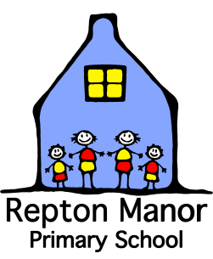

**Your Child’s Spring**

**Progress Report**

Child’s name:

Class: Teacher:

|  |  |
| --- | --- |
| **What do you enjoy doing at School?** | **Is there anything you don’t enjoy doing at School?** |
| **What do you think you are good at?** | **What do you find tricky?** |

*Child’s contribution*

|  |
| --- |
|  |

|  |
| --- |
| **Three key concepts that your child has achieved this term** |
| **The social development of your child** |

*Teacher’s contribution*

Your child’s attendance for this term until Friday 18th March 2022: %

The Governors, Headteacher and Staff in partnership with parents have a duty to promote full attendance at Repton Manor Primary School. As a school we will continually monitor your child’s attendance and will work with parents and outside agencies to support where we see a decline in attendance and/or punctuality.

Child’s name …………………………………

**Working in Partnership with My Parents**

|  |
| --- |
|  |
| Recently my child has been interested in:  Recently my child has learnt or is starting to learn how to:  What would you like your child to achieve over the coming term?  Recent or forthcoming special events in my child’s life (e.g. holidays/day trips/ birthdays):  Questions I would like to ask as a parent:  **Completed by …………………………………………………… Date completed …………………………** |

Thank you for sharing this information with us. Please return this page to your child’s teacher.

*Parent’s contribution*

If you would like to talk about your child’s learning, then please come and arrange a convenient time with your child’s teacher.

If you would like to talk about your child’s effort or attainment then please come and arrange a convenient time with your child’s teacher.