Here are the links for the video we watched:

https://www.youtube.com/watch?v=je7mlAzyD7A
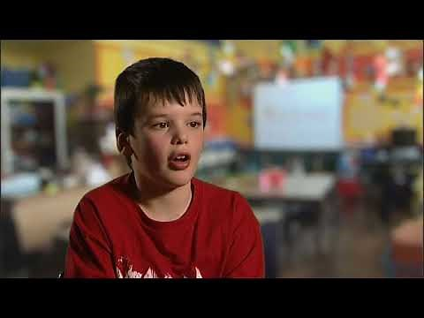   | Wait, wait, I'm not finished yet..(short version)  This 10 minute video was developed at the Michael Palin Centre as a resource for teachers and any others who want to know how to support a child who stammers or stutters. The children and young people who stutter tell you what they want you to know. This initiative was funded by the UK Department for Children, Schools and Families.  www.youtube.com

And another video for you to share with staff (contains swearing):

https://www.youtube.com/watch?v=xlDi0bMNV6g
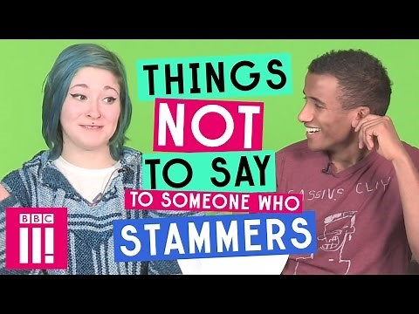   | Things Not To Say To Someone Who Stammers  Whether it's people finishing your sentences, or being told to "spit it out", here are nine things people with stammers are tired of hearing... -- Click here to subscribe to BBC Three: http://bit.ly/BBC-Three-Subscribe Did you know that we’re up to other things in other places too? Best of BBC Three: www.bbc.co.uk/bbcthree iPlayer: http://www ...  www.youtube.com

